ULTRASONIC TESTING REPORT
Company/Client |  | NCOC N. V. |  | Project |  | ESKENE WEST KARABATAN |  | Location |  | Workshop
Line No/Tag No: |  | Unit-210 Schlumberger package line |  | Material |  | Carbon steel |  | Día × Nominal Thickness |  | According to table
Procedure No |  | QP-11-UTT-Q01 Rev 03  GOST 28702-90 |  | Calibration Block |  | CS Step wedge |  | Probe  S/N |  | D7906  1058416
 |  |  |  | Calibration block Range |  | 2.50-25.00 mm |  | Angle |  | 0º
Manufacturing Code |  | ASME B31.3 |  | Calibration Temp |  | +25º |  | Frequency |  | 5 MHz
 |  |  |  | Object Temp |  | +25º |  | Size |  | 11 mm
Acceptance Standard: |  | Acc. to the client specif. |  | Correction factors |  | n/a |  | Crystal |  | Dual
Surface condition |  | Coated |  | Couplant |  | UT Gel |  | Accuracy |  | ± 0,1 mm
S. No | Equipment/  Material Name |  | Manufacturer |  | Serial No |  | Calibration certificate No |  | Calibration Expiry date
 | DL-38 |  | OLYMPUS |  | 171421601 |  | BK-01-0674 |  | 20-03-2020
 | Step wedge calibration block |  | NDE-TECH |  | NDE-8363 |  | - |  | -
Job description:

- UT spot check performed on line Schlumberger spools
- Inspection performed by scanning
UT spot check was done by echo to echo method.

Notes:
N/A – not applicable.
FSH - Full Screen Height

Photos
1
2
3
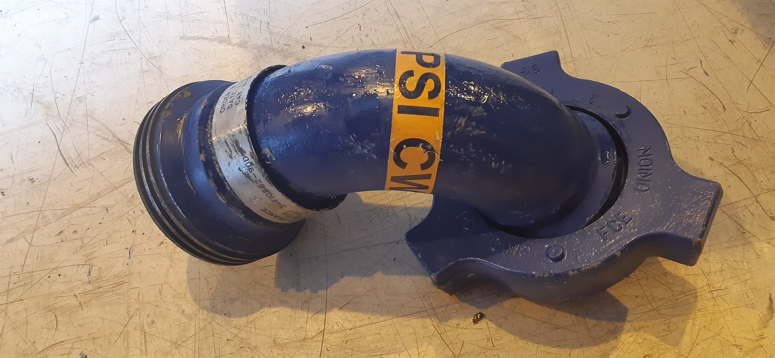

Results
S/NO | Line No | DIA(Ø), inch | Nominal thickness, mm* | Minimum
1 | Elbow-1 | 3″ | 7.62 | 6.00
2 | Elbow-1 | 3″ | 7.62 | 7.00
3 | Elbow-1 | 3″ | 7.62 | 6.5
1 | Elbow-2 | 3″ | 7.62 | 6.2
2 | Elbow-2 | 3″ | 7.62 | 6.7
3 | Elbow-2 | 3″ | 7.62 | 5.9

Examined by  UT L II cert. No 13180-2018-00 exp. date:11.07.2023 | Name: Ongarbayev Azimbek | Signature:…........................ | Date: 26-July-2019
Approved by  UT L III cert. No 1A 123/15  expiry date 29.02.2020 | Name: Shundryk Ihar | Signature: .......................... | Date: 26-July-2019
Client Representative: | Name: …………………………… | Signature: .......................... | Date: ……………

